**Assignment#03**

1. Write a program to create a binary search tree for N given data items as input (A binary search tree is a [rooted](https://en.wikipedia.org/wiki/Rooted_tree) [binary tree](https://en.wikipedia.org/wiki/Binary_tree), whose internal nodes each store a key (and optionally, an associated value) and each have two distinguished sub-trees, commonly denoted left and right. The tree additionally satisfies the binary search tree property, which states that the key in each node must be greater than or equal to any key stored in the left sub-tree, and less than or equal to any key stored in the right sub-tree).

Your program also performs the following operations on the binary search tree:

1. Traverse the tree in pre-order
2. Traverse the tree in in-order
3. Traverse the tree in post-order

Search the tree for a given key value and return “Yes” if the search is successful and “No” otherwise.

2. Suppose you are given graph G in the form of adjacency matrix. Write a program to determine the path matrix using Warshall’s Algorithm.

Example: For the graph:

Adjacency Matrix is:

X Y Z W

X

Y

Z

W



Path Matrix is:

X Y Z W

X

Y

Z

W



3. Suppose you are given graph G in the form of weight matrix. Write a program to determine the shortest path of the graph.

Example: For the graph:

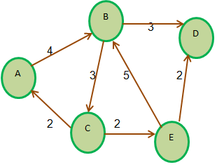

The weight matrix is:

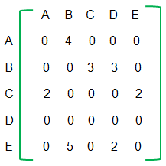

Shortest path from A to D is:

**A -> B -> D**